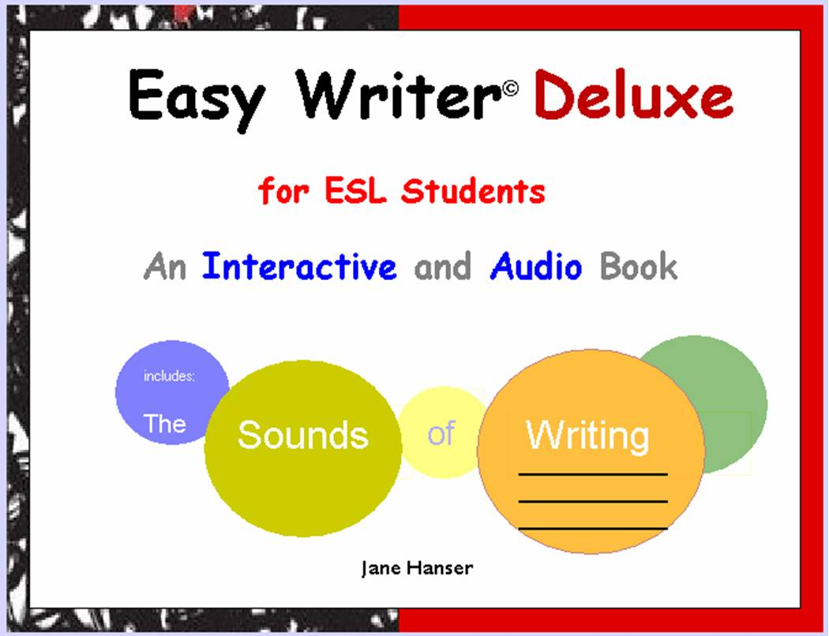
Bridge to Grammar EASY WRITER © by Jane Boris Hanser
You may use this reference to help you study grammar in The Grammar HELP! Student Handbook before, after, and during your work on each of the Easy Writer stories and essays. You may check off each grammar unit if you have read it and done all the associated exercises. Use the space provided for any notes you wish to take.
 | Study these units in the Student Handbook | (Date) Assigned | (Date) Completed
ARTICLES
Read Chapter 2, Articles, Sneak Preview. What Is an Article? Part One. Do Warm-up 1. What Is an Article? Part Two. Do Warm-up 2.
2-1 | Articles and Countable Nouns
2.1a | The Singular Countable Noun: a and an
2.1b | Singular Countable Nouns: the
2-2 | Articles and Plural Countable Nouns
2-2a | Plural Countable Nouns: No Article
2-2b | Plural Countable Nouns: the
2-4 | Names of…
2-4a | …Languages and Nationalities
4-5 | Demonstrative Adjectives
My First Week at College (B)

1-6d | some
2-1 | Articles and Countable Nouns
2.1a | The Singular Countable Noun: a and an
2-2 | Articles and Plural Countable Nouns
2-2a | Plural Countable Nouns: No Article
2-2b | Plural Countable Nouns: the
2-3 | Articles and Noncountable Nouns
2-3a | Noncountable Nouns: No Article
2-3b | Noncountable Nouns: the vs. No Article

Cross-country Skiing (B)

